PROJECT REPORT TEMPLATE

1 INTRODUCTION

* 1. Overview

The “Crafting Memorable Logos with Canva” project focuses on creating distinctive and impactful logos using Canva, a versatile graphic design tool. A well-designed logo serves as the visual cornerstone of a brand’s identity, representing its values, personality, and mission

* 1. Purpose

✓ Small and Convenient

✓ Affordable Advertisement

✓ Give A visual aid to Remember your business

✓ Business logos are a vital networking tool

✓ Logo Creates a professional imagescredible

1. Problem Definition & Design Thinking

2.1 Empathy Map

2.2 Ideation and Brainstorming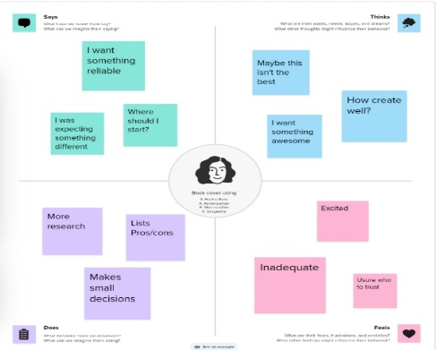

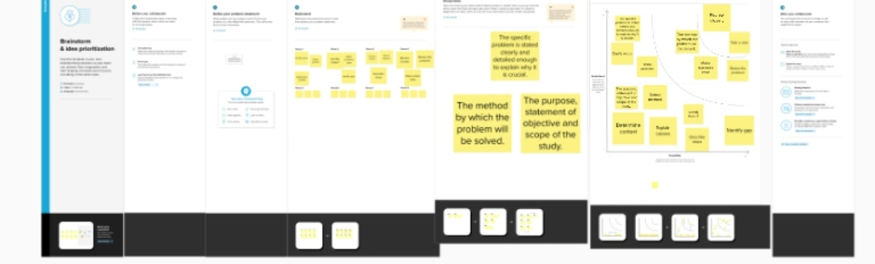

3**.Result**

**Logo designing**

4 ADVANTAGES & DISADVANTAGES

Advantages

* Canva is very simple to use and user friendly
* Canva provides social media templates
* Canva offers a professional look
* Team access
* As well as million of image

Disadvandage

* The free version is limited
* Unique elements cannot be created
* Limited export setting s
* Alignment concerns
* Unable to move one design to another design

5 APPLICATIONS

* We create a canva account
* Choose our design type
* And we used logo template
* We uploaded our backround image
* We used uploading photos, and adding text, and used to editing elements ,and change

Fonts

* Added to the icon , flower design of corner.
* We created a logo
* Finally we downloaded a design

6 CONCLUSION

Canva has thousands of logo templates you can customize to make your own. Choose a logo that resonates with you and feels connected to your brand.